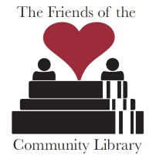
The Friends of The Community Library

Annual Basket Raffle - Sept. 25, 2021
Want to be a friend to The Community Library?
Would you consider donating a basket as part of our annual event?
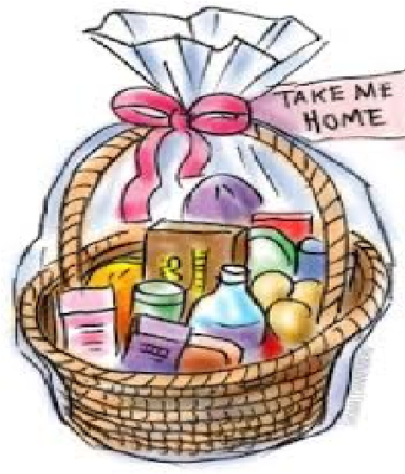
The Friends of The Community Library are again preparing for our biggest fund-raiser of the year.
We’d love it if you could join our effort and help the library by donating a basket of goodies to be raffled off. We’ll credit you by listing the name on a card displayed with the basket.
Each basket or decorative container:
- must be based on a theme of your choice
- needs to include at least one book
- has to have a value of at least $50
- can be for children, families, or adults

If you can’t find the right receptacle, you can donate the items that go inside and we’ll find a basket or container that works for your items! If you’re interested in donating a basket, complete and return the attached “Basket Donation Form” to The Community Library or notify The Friends of your intention by June 30, 2021, by emailing The Friends at friendscommunitylibrary@gmail.com or call Kim Walchko at 518-234-4192. If there are any questions, please contact us. Thank you!
Basket Raffle Timeline:
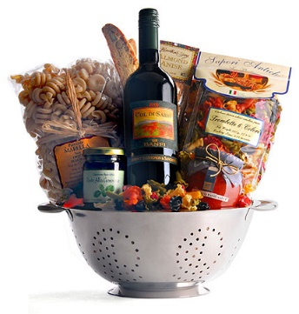
August 10, 2021 – August 14, 2021
Drop off baskets at the library during regular library hours:
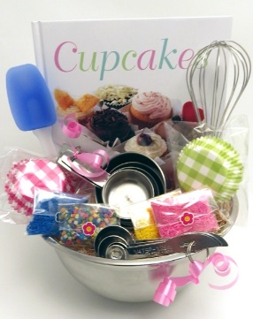
Tues. & Thurs. 10:00 AM – 7:00 PM
Wed. & Fri. 10:00 AM – 5 PM
Sat. 10:00 AM – 1:00 PM
Closed Sun. & Mon.

Tuesday, August 31, 2021
Basket raffle officially begins. Baskets are on display and raffle tickets go on sale.
Saturday, September 25, 2021 9 AM to 12 PM
Raffle drawing, book sale, and more at The Community Library, 110 Union St., Cobleskill.

